Paper Bundle Distribution Management System
Final Application, Database and Workflow Documentation
This document consolidates the original requirements and the implemented Version 4 enhancements into a single application reference. It describes the ASP.NET Core MVC application, SQL Server database, approval workflow, dynamic paper-type quotas, notifications, user interface standards, reporting and operational controls.
Document control | Value
Version | Final / Implementation Reference
Application | ASP.NET Core MVC
Database | Microsoft SQL Server
Module | Paper Management
Prepared date | August 2026
Primary audience | Business owners, IT operations, developers and testers

1. Executive Summary
The Paper Bundle Distribution Management System replaces manual paper-distribution records with a controlled digital process for requesting, reviewing, approving, issuing and reporting paper bundles. The supplied implementation is an ASP.NET Core MVC web application backed by Microsoft SQL Server and accessed through role-controlled browser screens.
The system is designed around a complete request lifecycle. A department submits a request for a selected paper type and quantity. The request is reviewed by IT, then moves through two configured approval stages. Once approved, IT or an administrator can issue the paper, at which point the physical inventory is checked and the issue transaction is recorded.
A key business rule is the monthly quota per Department × Paper Type. The database reserves quantities for active requests and uses transactional locking during quota and inventory operations to reduce the risk of over-allocation under concurrent use.
- Arabic-first user interface with role-specific screens and status presentation.
- Cookie-based authentication with BCrypt password hashing.
- Server-side authorization plus database-level approval-stage validation.
- A rejection-mediation workflow: IT can resend a rejected request for another approval pass, or finalize the rejection.
- A full chronological activity log per request (RequestActivityLog), independent of the individual note fields, recording every submit / review / approve / reject / resend / issue event with who performed it and when.
- Quota-exempt exception requests, for cases that must bypass the monthly quota by design.
- Inventory receipt history, current stock balances and configurable low-stock thresholds.
- Dynamic usage reports filtered by date, department and paper type.
- Administrative management of departments (including deletion), users, paper types, quotas and fixed approval-stage assignments.
The supplied portal also contains navigation for other resource-management areas, but those areas are outside the implemented Paper Management scope reviewed for this document.

2. Purpose, scope and objectives

2.1 Purpose
The primary purpose is to provide a traceable, quota-controlled workflow for paper distribution. Every material business event request submission, IT review, approval, rejection, receipt of stock and issue of paper is represented in the application or database so that operational history can be reconstructed.

2.2 scope
Capability | Business outcome
Paper request submission | Department users submit requests; IT/Admin can also submit on behalf of a department.
Exception requests | IT/Admin can submit a request that intentionally bypasses the monthly quota check, for genuine one-off needs, while still going through IT review, approval and issue.
IT review | IT/Admin reviews incoming requests, may adjust the quantity, add review notes, or reject the request.
Approval workflow | Requests move through two approval stages. Each stage is assigned to a configured Approver account; Admin is also permitted by the database procedure.
Rejection mediation | A rejection by either approver returns the request to IT rather than closing it. IT can resend it (with an updated quantity/note) back into the approval flow, or finalize the rejection permanently.
Paper issue | Approved requests are issued by IT/Admin. Stock is checked and deducted atomically, and an issue transaction is recorded.
Inventory | IT/Admin receives stock, views current balances, manages paper types and configures low-stock thresholds.
Quota management | Admin manages monthly quotas for each Department × Paper Type combination.
User and department administration | Admin creates, deactivates, reactivates, deletes and resets users and manages departments.
Reporting | IT/Admin can generate date-filtered usage reports with department rows and dynamic paper-type columns.
History, notes and activity log | Request history, a per-stage stack of notes (department / IT / each approver / rejection / issuing), and the full chronological RequestActivityLog support operational follow-up.

2.3 Out of scope
- Leave management, supplies tracking and device management are represented as portal concepts but are not part of the supplied Paper Management implementation.
- The documentation does not describe functionality that is absent from the supplied source code and database script.

3. Business Roles and permissions
Role | Primary permissions | Restrictions
Department | Submit requests for its assigned department; view request status/history and department notifications. | Cannot approve, issue stock, manage users, manage quotas or alter inventory.
IT | Review requests, adjust reviewed quantity, reject during IT review, receive stock, issue approved paper and access operational reports. | Cannot perform approval-stage actions unless the account also has the Admin role.
Approver | Process the approval stage assigned to the account; approve or reject and record an optional note. | The database validates the account against FixedRequestApprover for the active stage.
Admin | User and department administration plus IT operational functions, quota management and approval-stage assignment. | Administrative approval is permitted by the approval procedures; fixed stage assignments remain configurable.

Account model
Department accounts are associated with a DepartmentID. The database enforces a unique non-null DepartmentID per user, so the current implementation supports at most one user account per department. Non-department roles are created without a department assignment in the supplied controller.

3.1 Use case diagram
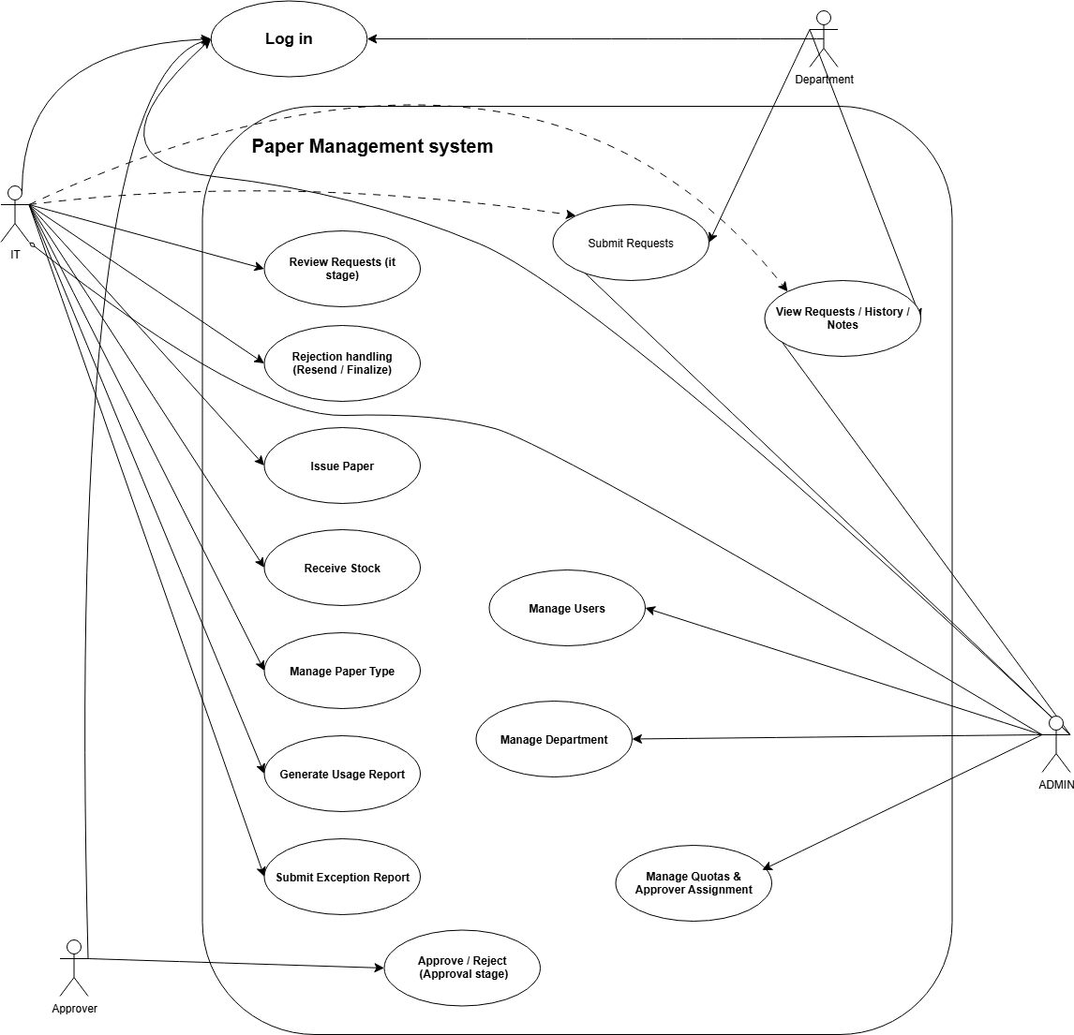
Admin can also perform every IT and Approver use case (shown with dashed 'also permitted' lines), in addition to its own exclusive administrative use cases.
Figure 1 – use case diagram

4. End-to-end business workflow

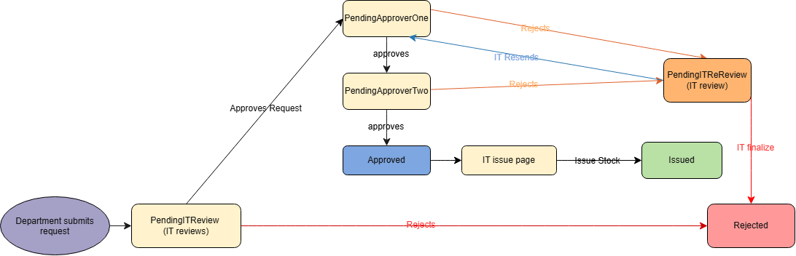
4.1 Primary workflow
Figure 2 – Full request lifecycle
Stage | System action | Resulting status
1. Department Submit | Validate Department x Paper Type monthly quota; create request. | PendingITReview
2. IT review | Validate reviewed quantity, add IT note and route to first dean. | PendingApproverOne
3. Approver stage 1 | Approve with optional note, or reject with reason. | Approve → PendingApproverTwo Reject → PendingITReReview
4. Approver stage 2 | Approve with optional note, or reject with reason. | Approve → Approved Reject → PendingITReReview
5. IT mediates a rejection | IT reviews the rejection reason and either resends the request (adjust quantity/note, quota re-checked) or finalizes the rejection. | Resend → PendingApproverOne Finalize → Rejected
6. IT/Admin issues | Validate available stock, create issue transaction and deduct stock. | Issued
7. History/Report | Issue transaction and request history remain available for reporting | Shown in History / Reports / printing

4.2 Quota Rule
Quota is defined for a department × Paper Type pair. At request creation, the system identifies the current calendar month, sums quantities from active request states for the same department and paper type, and rejects the new request when the configured limit would be exceeded.
Active quota states
PendingITReview, PendingApproverOne, PendingApproverTwo, Approved and Issued reserve quota. Rejected requests do not reserve monthly quota.

4.3 Inventory Rule
Stock receipt increases both TotalReceived and CurrentStock. Issue processing requires the request to be Approved and performs an atomic stock decrement only when sufficient CurrentStock exists. The issue transaction and request status are written within the same transaction.

4.4 Rejection Paths
- IT can reject a request outright while it is PendingITReview - this goes straight to the terminal Rejected state, since the request never reached an approver.
- An Approver can reject during either approval stage - this routes the request to PendingITReReview rather than closing it immediately.
- From PendingITReReview, IT can resend the request (sp_ResendForApproval) back to Approver 1 with an updated quantity/note, re-checking quota, or finalize it (sp_FinalizeRejection) into the terminal Rejected state.
- A request can cycle through rejection and resend more than once; each stage's notes accumulate rather than overwrite one another (see section 6.4).
- Rejected requests remain in request history and cease reserving monthly quota.

5. Functional Requirements
Area | Requirement
Authentication | The system shall authenticate users by username and password and create an authenticated cookie session.
Password protection | Passwords shall be stored as BCrypt hashes rather than plain text.
Role authorization | Protected controllers/actions shall enforce role-based access.
Request creation | Authorized users shall create requests with paper type, positive quantity and optional notes.
Exception requests | IT/Admin shall be able to submit a request that bypasses monthly quota validation, with a mandatory justification note.
Department scoping | Department users shall submit against their own DepartmentID; IT/Admin may select the beneficiary department.
Quota enforcement | Request creation and IT review shall enforce the configured Department × Paper Type monthly quota.
IT review | IT/Admin shall review a request, adjust quantity, add a review note and route it to approval.
Approval | The two configured approval stages shall be processed in order.
Rejection | IT or the active approval-stage approver shall be able to reject according to the current request status.
Rejection mediation | IT shall be able to resend a rejected request back into the approval flow, or finalize the rejection, from PendingITReReview.
Issue | IT/Admin shall issue approved requests only when sufficient stock exists.
Inventory receipt | IT/Admin shall record incoming stock and maintain an inventory receipt history.
Paper types | Admin shall be able to add and delete paper types subject to database safeguards.
Quota administration | Admin shall maintain quota values for each Department × Paper Type pair.
Approver assignment | Admin shall assign the user responsible for each approval stage.
User administration | Admin shall create, disable, reactivate, delete and reset passwords for users.
Department administration | Admin shall be able to create and delete departments; deletion is blocked while the department has request history.
Reporting | IT/Admin shall generate usage reports filtered by period, department and paper type.
Notifications | Relevant users shall receive lightweight in-page request notifications.
Auditability | Requests, approvals, receipts and issue transactions shall retain dates, users and notes where supported by the schema.

6. Application design and screens

6.1 Navigation and interaction design
The supplied application is Arabic-first (HTML dir=rtl/lang=ar) and uses Razor views with Tailwind CSS utilities, Bootstrap Icons and a consistent application layout. The paper module uses a common navigation layout and status-badge component.
Screen | Audience | Purpose
Login | All users | Username/password authentication and remember-me option.
Change Password | Users with temporary-password flag | Forces the user to replace a temporary password before continuing.
Access Denied | Authenticated users | Displayed when the current role cannot access a protected resource.
Paper Dashboard | IT/Admin | Pending counts, approved count, issued quantities and inventory status.
Submit Request | Department / IT / Admin | Select paper type and quantity; IT/Admin can choose the beneficiary department.
IT Review Queue | IT/Admin | Review pending requests, set reviewed quantity, add notes and reject when required.
Approval Queue | Approver | Shows requests assigned to the logged-in approval stage and provides approve/reject actions with notes.
Issue Queue | IT/Admin | Shows Approved requests and allows final issue quantity plus issue notes.
Inventory | IT/Admin | Current stock, cumulative receipts, paper type management, low-stock threshold and stock receipt.
Receipt Log | IT/Admin | Historical stock receipt records.
Request History | Authorized paper users according to controller policy | Filtered request history.
Last Issued / Pending | Paper users according to controller policy | Operational view of issued and pending requests; the current shared navigation hides these legacy links.
Reports | IT/Admin | Date-range and optional department/paper-type filtered usage report with dynamic columns.
Department Management | IT/Admin | Department creation/deletion, Department × Paper Type quotas and fixed approval-stage assignment.
User Management | Admin | Create, deactivate, reactivate, delete and reset user accounts.

6.2 Status presentation
Internal value | UI label
PendingITReview | قيد المراجعة
PendingApproverOne | قيد اعتماد المقدم محمد
PendingApproverTwo | قيد اعتماد العميد حسني
PendingITReReview | مرفوض - بانتظار مراجعة IT
Rejected | مرفوض
Issued | تم الصرف
Approved | جاهز للصرف

6.3 Interface Controls
- Anti-forgery tokens are included on state-changing Razor forms.
- Quantity inputs are constrained in the view and validated again server-side/database-side.
- Filters are available for department, paper type, status, date and search keyword where supported.
- Inventory cards expose current stock and low-stock status.
- Approval and issue actions open request details before the final action.
- NotificationFeed returns a lightweight JSON list used for in-page notifications rather than a separate notification page.

7. Technical architecture

7.1 Technology Stack
Component | Implementation
Application framework | ASP.NET Core MVC
Target framework | net10.0
Language | C#
Database | Microsoft SQL Server
Data access | Microsoft.Data. SqlClient through a centralized DbHelper
Authentication | ASP.NET Core Cookie Authentication
Password hashing | BCrypt.Net-Next 4.2.0
Presentation | Razor Views, Tailwind CSS utilities, Bootstrap Icons, JavaScript
Database access pattern | Stored-procedure-only controller access through DbHelper

7.2 Logical architecture
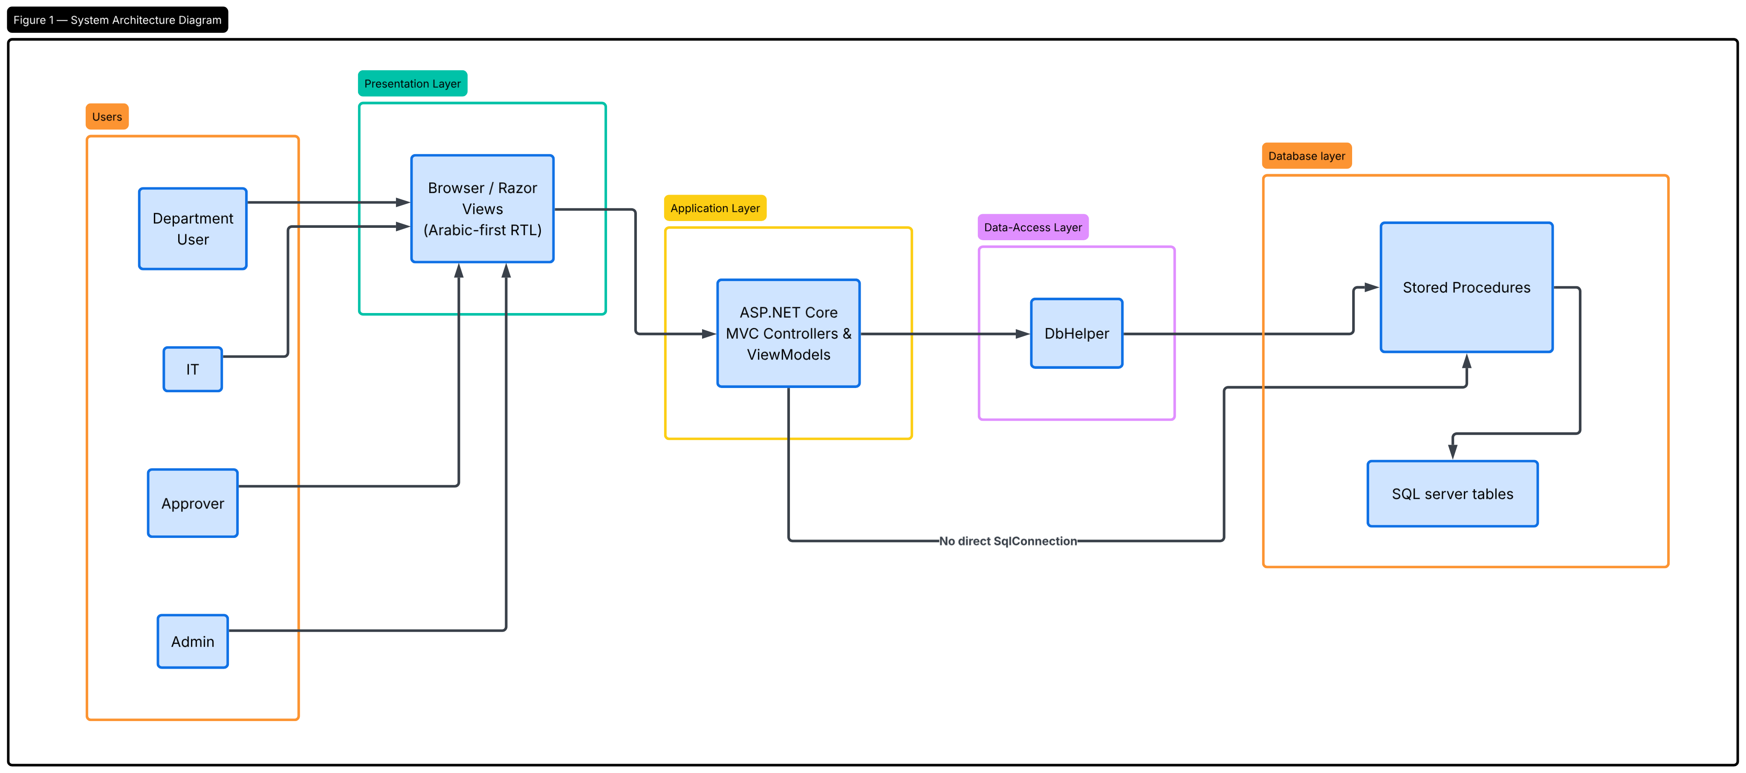
figure 3 – logical architecture

7.3 Application Structure
Source component | Responsibility
Areas/PaperManagement/Controllers/RequestController.cs | Core paper request workflow, inventory, issue and reporting actions.
Areas/PaperManagement/Controllers/DepartmentManagementController.cs | Departments, quotas and fixed approval-stage assignments.
Controllers/AccountController.cs | Login, logout and password-change flow.
Controllers/UserManagementController.cs | User administration.
Data/DbHelper.cs | Single database access point for stored procedures.
Models/PaperRequestModels.cs | View models for requests, inventory, reports and filters.
common/AppConstants.cs | Centralized role and request-status constants.
common/PasswordHelper.cs / StatusDisplayHelper.cs | BCrypt hashing/verification; status-to-label/CSS mapping.
Views/Shared/_StatusBadge.cshtml | Reusable status display.
Areas/PaperManagement/Views/Shared/_NotesStack.cshtml | Reusable ordered/labelled notes display, shared across the Review Queue, Approval Queue and Issue Queue.
Areas/PaperManagement/Views/Shared/_PaperLayout.cshtml | Paper module layout, navigation and UI conventions.

7.4 Request Processing Pattern
Controllers do not open SqlConnection objects directly. They call named stored procedures through DbHelper, which creates the connection, sets CommandType.StoredProcedure, adds strongly named SqlParameter objects (including output parameters, e.g. sp_ApproveRequest's @ResultStage) and executes the command as a DataTable, DataSet or non-query.
Design principle
Business-critical rules such as quota validation, approval-stage authorization, stock checks and inventory updates are implemented in SQL procedures rather than relying only on browser validation.

8. Database design
The database is centered on users and roles, departments, paper types, quota mappings, requests, approval records and inventory transactions.

8.1 Entity relationship diagram
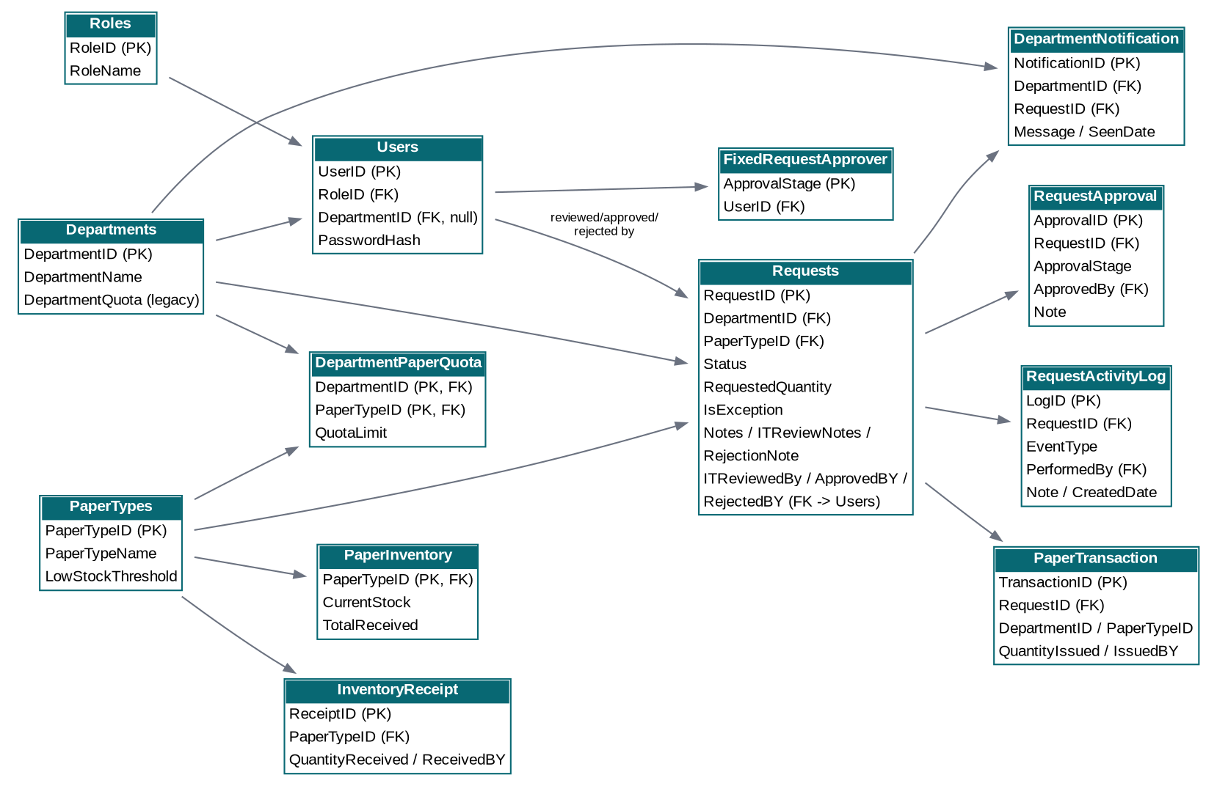
Figure 4 – ERD
Table | Key fields | Purpose
Roles | DepartmentID, PaperTypeID, QuotaLimit | Controlled role names: Department, IT, Admin and Dean.
Users | RequestID, DepartmentID, PaperTypeID, RequestedQuantity, Status, IsException, Notes, ITReviewNotes, RejectionNote | User identity and role/department assignment.
Departments | ApprovalID, RequestID, ApprovalStage, ApprovedBy, Note | Department master record; legacy quota is retained as a default.
PaperTypes | LogID, RequestID, EventType, PerformedBy, Note, CreatedDate | Configurable paper categories.
DepartmentPaperQuota | PaperTypeID, TotalReceived, CurrentStock, LastUpdated | Version 4 dynamic quota bridge table.
Requests | ReceiptID, PaperTypeID, QuantityReceived, ReceivedDate, ReceivedBY | Workflow record from submission through issue or rejection.
RequestApproval | TransactionID, RequestID, DepartmentID, PaperTypeID, QuantityIssued, IssueDate, Notes | Two dean-stage approvals and their notes.
RequestActivityLog | NotificationID, DepartmentID, RequestID, Message, CreatedDate, SeenDate | Current stock snapshot per paper type.
PaperInventory | ApprovalStage, UserID | Current stock snapshot per paper type.
InventoryReceipt | DepartmentID, PaperTypeID, QuotaLimit | Audit trail for incoming paper stock.
PaperTransaction | RequestID, DepartmentID, PaperTypeID, RequestedQuantity, Status, IsException, Notes, ITReviewNotes, RejectionNote | Audit trail for issued paper.
DepartmentNotification | ApprovalID, RequestID, ApprovalStage, ApprovedBy, Note | Department-facing change notifications.
FixedRequestApprover | LogID, RequestID, EventType, PerformedBy, Note, CreatedDate | Configured user for each approval stage.

8.2 Integrity Controls
- Primary keys exist on all core tables; DepartmentPaperQuota uses a composite primary key of DepartmentID + PaperTypeID.
- Foreign keys protect department, user, paper type, request and inventory relationships.
- CHECK constraints require positive request, receipt and issue quantities and non-negative stock/quota thresholds.
- Request status is constrained to the seven implemented lifecycle values, including PendingITReReview.
- UNIQUE constraints protect role names, department names, paper type names, usernames and fixed approver assignments.
- The filtered unique index UQ_Users_OneUserPerDepartment prevents more than one non-null department assignment in Users.
- Transactions with UPDLOCK/HOLDLOCK are used by critical quota and issue procedures to reduce concurrent over-reservation.

9. Quota validation sequence
This is the logic executed by sp_SubmitRequest, sp_ITReviewRequest, sp_ResendForApproval and sp_UpdateRequestQuantity wherever quota must be (re)checked. sp_SubmitExceptionRequest deliberately skips this entirely.
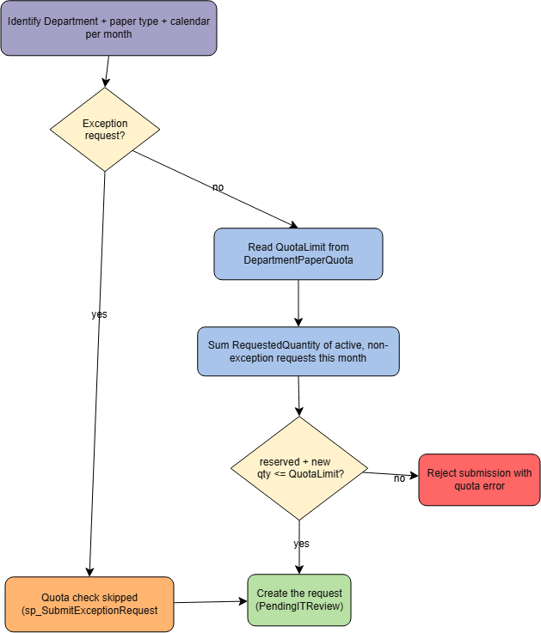
Figure 5 – quota validation sequence

10. Database Table Dictionary

10.1 DepartmentNotification

Department-facing request notifications.
Column | SQL type | Nullability | Default / note
NotificationID | int | NOT NULL / IDENTITY or key-defined | —
DepartmentID | int | NOT NULL | —
RequestID | int | NOT NULL | —
Message | nvarchar(500) | NOT NULL | —
CreatedDate | datetime2(7) | NOT NULL | sysdatetime
SeenDate | datetime2(7) | NULL | —

10.2 DepartmentPaperQuota

Monthly quota by Department × Paper Type.
Column | SQL type | Nullability | Default / note
DepartmentID | int | NOT NULL | —
PaperTypeID | int | NOT NULL | —
QuotaLimit | int | NOT NULL | (0)

10.3 Departments

Department master data and legacy/default quota field.
Column | SQL type | Nullability | Default / note
DepartmentID | int | NOT NULL / IDENTITY or key-defined | —
DepartmentName | nvarchar(100) | NOT NULL | —
DepartmentQuota | int | NOT NULL | —

10.4 FixedRequestApprover

Configured user for each approval stage.
Column | SQL type | Nullability | Default / note
ApprovalStage | tinyint | NOT NULL | —
UserID | int | NOT NULL | —

10.5 InventoryReceipt

Audit history for incoming stock.
Column | SQL type | Nullability | Default / note
ReceiptID | int | NOT NULL / IDENTITY or key-defined | —
PaperTypeID | int | NOT NULL | —
QuantityReceived | int | NOT NULL | —
ReceivedDate | datetime | NOT NULL | —
ReceivedBY | int | NOT NULL | —

10.6 PaperInventory

Current and cumulative stock snapshot by paper type.
Column | SQL type | Nullability | Default / note
PaperTypeID | int | NOT NULL | —
TotalReceived | int | NOT NULL | —
CurrentStock | int | NOT NULL | —
LastUpdated | datetime | NOT NULL | —

10.7 PaperTransaction

Audit history for issued paper.
Column | SQL type | Nullability | Default / note
TransactionID | int | NOT NULL / IDENTITY or key-defined | —
RequestID | int | NOT NULL | —
DepartmentID | int | NOT NULL | —
PaperTypeID | int | NOT NULL | —
QuantityIssued | int | NOT NULL | —
IssueDate | datetime | NOT NULL | —
IssuedBY | int | NOT NULL | —
Notes | nvarchar(500) | NULL | —

10.8 PaperTypes

Configurable paper categories and low-stock threshold.
Column | SQL type | Nullability | Default / note
PaperTypeID | int | NOT NULL / IDENTITY or key-defined | —
PaperTypeName | nvarchar(20) | NOT NULL | —
LowStockThreshold | int | NOT NULL | (50

10.9 RequestActivityLog
Column | SQL type | Nullability | Default / note
LogID | int | NOT NULL / IDENTITY or key-defined | —
RequestID | Int | NOT NULL | —
EventType | Nvarchar(50) | NOT NULL | __
PerformedBy | Int | NULL | __
Note | Nvarchar(500) | NULL | __
CreatedDate | Datetime2(7) | NOT NULL | __

10.10 RequestApproval

Approval-stage decisions and notes.

Column | SQL type | Nullability | Default / note
RequestID | int | NOT NULL | —
ApprovalStage | tinyint | NOT NULL | —
ApprovedBy | int | NOT NULL | —
ApprovedDate | datetime2(7) | NOT NULL | sysutcdatetime
Note | nvarchar(500) | NULL | —
ApprovalID | Int | NOT NULL / IDENTITY | __

10.11 Requests

End-to-end paper request and lifecycle data.

Column | SQL type | Nullability | Default / note
RequestID | int | NOT NULL / IDENTITY or key-defined | —
DepartmentID | int | NOT NULL | —
PaperTypeID | int | NOT NULL | —
RequestedQuantity | int | NOT NULL | —
Status | nvarchar(30) | NOT NULL | N'PendingITReview'
Notes | nvarchar(500) | NULL | —
RequestDate | datetime | NOT NULL | —
ApprovedDate | datetime | NULL | —
ApprovedBY | int | NULL | —
RejectedDate | datetime | NULL | —
RejectedBY | int | NULL | —
IssuedDate | datetime | NULL | —
ITReviewedDate | datetime2(7) | NULL | —
ITReviewedBy | int | NULL | —
ITReviewNotes | nvarchar(500) | NULL | —
IsException | Bit | NOT NULL | __
RejectionNote | Nvarchar(500) | NULL | __

10.12 Roles

System role master data.
Column | SQL type | Nullability | Default / note
RoleID | int | NOT NULL / IDENTITY or key-defined | —
RoleName | nvarchar(50) | NOT NULL | —

10.13 Users

Authentication identity, role and department assignment.
Column | SQL type | Nullability | Default / note
UserID | int | NOT NULL / IDENTITY or key-defined | —
UserName | nvarchar(50) | NOT NULL | —
PasswordHash | nvarchar(256) | NOT NULL | —
RoleID | int | NOT NULL | —
DepartmentID | int | NULL | —
MustChangePassword | bit | NOT NULL | (0
IsActive | bit | NOT NULL | (1

11. Stored Procedure Catalogue
Procedure | Area | Purpose
sp_GetUserForLogin | Authentication | Returns user, role, department and account flags for login.
sp_ChangeOwnPassword | Authentication | Updates the current user's password hash.
sp_CreateUser / sp_DeleteUser | Administration | Creates or deletes a user account.
sp_DeactivateUser / sp_ReactivateUser | Administration | Changes account active state.
sp_ResetUserPassword | Administration | Replaces a user's password hash.
sp_GetAllUsersWithDetails | Administration | Returns user list with role/department details.
sp_GetRoles / sp_GetDepartments | Administration | Returns selection-list master data.
sp_CreateDepartment / sp_DeleteDepartment | Administration | Creates a department (seeding quota rows for existing paper types) or deletes one, blocked while request history exists.
sp_GetDepartmentPaperQuotas / sp_UpdateDepartmentPaperQuota | Quota management | Returns or updates the Department × Paper Type quota matrix.
sp_UpdateDepartmentQuota | Quota management | Updates a department's legacy/default quota value (Departments.DepartmentQuota); day-to-day enforcement uses the per-paper-type quota instead.
sp_SetFixedRequestApprover / sp_GetApproverUsers / sp_GetFixedRequestApprovers | Approval administration | Assigns and reports the user responsible for each approval stage.
sp_CreatePaperType / sp_DeletePaperType | Inventory administration | Creates a paper type (seeding inventory and quota rows) or deletes one, blocked while dependent history exists.
sp_SetPaperTypeLowStockThreshold / sp_GetPaperTypes | Inventory administration | Updates the low-stock threshold; returns paper-type master data.
sp_GetInventoryStatus / sp_ReceiveStock / sp_GetInventoryReceiptLog | Inventory | Returns current stock; records a receipt and atomically increases stock; returns receipt history.
sp_SubmitRequest | Workflow | Creates a PendingITReview request after Department × Paper Type quota validation; logs a Submitted activity entry.
sp_SubmitExceptionRequest | Workflow | Creates a PendingITReview request that bypasses quota validation entirely, requiring a mandatory justification note.
sp_ITReviewRequest / sp_RejectRequestByIT | Workflow | Revalidates quantity/quota and routes to Approver 1, or rejects outright while still PendingITReview.
sp_GetPendingRequestsForApprover | Workflow | Returns requests for the logged-in user's configured approval stage, with the notes stack so far.
sp_ApproveRequest | Workflow | Processes stage 1 or stage 2 approval, stores the decision note, and returns which stage just completed (@ResultStage output).
sp_RejectRequest | Workflow | Rejects a request at the active approval stage, storing the rejection reason and routing it to PendingITReReview.
sp_ResendForApproval | Workflow | IT resends a PendingITReReview request back to Approver 1 with a re-validated quantity and an appended IT note.
sp_FinalizeRejection | Workflow | IT closes a PendingITReReview request permanently as Rejected.
sp_UpdateRequestQuantity | Workflow | Adjusts an Approved request while rechecking its monthly quota.
sp_IssueRequest | Workflow / inventory | Issues an Approved request, checks stock atomically, creates the issue transaction with its own note, and updates the request.
sp_GetFilteredRequests | History | Returns filtered request records - including all notes fields and role-based attribution - for the operational queues and history.
sp_GetRequestActivityLog | History | Returns the full chronological activity trail for one request.
sp_GetDashboardStats | Dashboard | Returns request counts, issued quantities and inventory status.
sp_GetDepartmentNotifications / sp_GetDepartmentLatestIssue | Notifications / history | Returns notifications, and the latest issue information, for a department.
sp_GetApprovedRequestsForIssue | Issue queue | Returns approved requests ready for issue.
sp_GetUsageReport | Reporting | Aggregates issued quantities by department and paper type for a date-filtered report, optionally narrowed to one department and/or one paper type.
sp_GetDepartmentQuotaStatus | Quota / reporting | Returns department quota usage status.

12. Reporting and printing

12.1 Usage Report
The report calls sp_GetUsageReport with optional FromDate, ToDate, DepartmentID and PaperTypeID filters. The controller pivots the returned rows into one row per department and one dynamic column per paper type that has usage in the result set; selecting a single paper type narrows the report to that type and shows it in the printed header.
Report element | Implementation | Behavior
Period filters | FromDate / ToDate | Applied to PaperTransaction.IssueDate.
Department filter | DepartmentID | Limits issued transactions to one department.
Paper type filter | PaperTypeID | Limits issued transactions to one paper type.
Dynamic columns | PaperTypeName | Controller builds the visible paper-type columns from returned usage rows.
Department row total / Column totals / Grand total | Calculated in MVC | Sums across the displayed paper-type columns, departments and overall.

12.2 Inventory Monitoring
- CurrentStock is compared with LowStockThreshold to identify low stock.
- CurrentStock at or below zero is displayed as out of stock.
- Receipt history records quantity, date and receiving user.
- Issue history records request, department, paper type, quantity, date, issuing user and notes.

12.3 Notifications
The NotificationFeed endpoint retrieves requests for the configured approval stage (Approver users) or requests awaiting IT review (IT/Admin). Department users retrieve DepartmentNotification records on the request-creation screen.

12.4 Printing
The report screen is intended for browser printing. The application controls the report layout, while browser-generated headers and footers remain browser print settings rather than application data.

13. Security and Data Integrity
Control area | Implementation
Authentication | ASP.NET Core Cookie Authentication; login uses sp_GetUserForLogin and BCrypt verification.
Password storage | BCrypt hashes are stored in Users.PasswordHash; plain-text comparison/storage is not used.
Authorization | Controllers and actions use [Authorize] with centralized role constants.
Approval authorization | sp_ApproveRequest and sp_RejectRequest validate the active stage against FixedRequestApprover; Admin is explicitly permitted by the procedure.
CSRF protection | State-changing Razor forms include ValidateAntiForgeryToken.
Input validation | View models apply Required, Range, MinLength and StringLength attributes; SQL procedures repeat critical quantity and status validation.
Database integrity | Primary keys, foreign keys, unique constraints and CHECK constraints protect relationships and business values.
Concurrency | Quota and issue procedures use transactions and locking patterns around the data that must not be over-allocated.
Account lifecycle | Accounts have IsActive and Department accounts can be forced through an initial password change.
Transport | The application enables HTTPS redirection in Program.cs and HSTS outside development.

Configuration safety
The application reads the database connection string from appsettings.json under the key PaperDb. Production deployment should keep environment-specific connection details outside source control and use the deployment environment's secure configuration mechanism.

14. Deployment and Configuration

14.1 Application Prerequisites
- .NET runtime/hosting environment compatible with net10.0.
- Microsoft SQL Server instance compatible with the supplied database script.
- Network access from the application host to the SQL Server instance.
- HTTPS certificate/configuration appropriate to the deployment environment.
- Static-file and Razor view hosting enabled by the ASP.NET Core application.

14.2 Database Setup
- Back up the target SQL Server database if an existing environment is being upgraded.
- Execute the supplied SQL database script against the intended SQL Server environment.
- Confirm that database [Paper Managment] exists and that the expected tables, constraints and stored procedures were created.
- Verify the connection string named PaperDb points to the intended SQL Server and database.
- Create or validate the required roles, departments, paper types and approval-stage assignments through the application.
- Create test stock receipts and test requests before production use.

14.3 Application Configuration
Setting | Purpose
ConnectionStrings:PaperDb | Database connection used by DbHelper.
AllowedHosts | ASP.NET Core allowed-host configuration.
Authentication | Cookie scheme configured in Program.cs; session expiration is 8 hours.
Target framework | net10.0.

14.4 Deployment Acceptance Checks
- Application starts without configuration errors; login succeeds with an active test account.
- Department accounts are forced to change temporary passwords when the database flag is set.
- Paper types and departments load correctly; quota matrix shows a row for each current Department × Paper Type pair.
- Approval stage 1 and stage 2 assignments are configured.
- Inventory receipt increases CurrentStock and creates a receipt record.
- A complete test request moves through review, both approvals and issue.
- A test rejection at each stage correctly reaches PendingITReReview, and both resend and finalize work from there.
- An exception request bypasses quota validation and still completes the normal review/approval/issue flow.
- Usage report returns the issued quantity for the test transaction, and the paper-type filter narrows it correctly.
- A department with no request history can be deleted; one with history is correctly blocked.

15. Testing and User Acceptance

15.1 UAT Scenarios
Scenario | Test action | Expected result
Valid request | Submit a quantity within the configured quota. | Request is created as PendingITReview.
Quota exceeded | Submit a quantity that exceeds the remaining monthly Department × Paper Type quota. | Submission is rejected with a quota error.
Exception request | Submit an exception request exceeding quota, with a justification note. | Request is created regardless of quota; IsException = 1.
IT review | Review a pending request and set a valid reviewed quantity. | Request becomes PendingApproverOne and IT review data is stored.
IT rejection | Reject a PendingITReview request. | Request becomes Rejected and rejection user/date are recorded.
Stage 1 approval | Approve a PendingApproverOne request as the assigned approver. | Request becomes PendingApproverTwo and stage-1 approval is stored.
Stage 1 rejection | Reject a PendingApproverOne request. | Request becomes Rejected and decision note is stored.
IT resends after rejection | From PendingITReReview, IT adjusts quantity/note and resends. | Request becomes PendingApproverOne again; the earlier rejection reason remains visible in the notes stack.
IT finalizes a rejection | From PendingITReReview, IT finalizes instead of resending. | Request becomes Rejected permanently.
Stage 2 approval | Approve a PendingApproverTwo request as the assigned approver. | Request becomes Approved.
Unauthorized approver | Attempt approval using an account not assigned to the active stage. | Database procedure rejects the action.
Issue with stock | Issue an Approved request with enough stock. | Stock decreases and a PaperTransaction is created; request becomes Issued.
Issue without stock | Attempt issue when CurrentStock is insufficient. | Transaction is rolled back and request remains Approved.
Receive stock | Receive a positive quantity. | Inventory receipt is created and CurrentStock/TotalReceived increase.
Paper type creation | Create a new paper type with a default quota. | Paper type and inventory are created; quota rows are seeded for existing departments.
Department creation/deletion | Create a department; later delete one with no requests. | Department is created with seeded quota rows; deletion succeeds only when no request history exists.
Report | Run a report for a date range containing issued transactions. | Department and paper-type usage totals are displayed.
Account disable | Disable an active account and attempt login. | Login is rejected for the inactive account.
Initial password | Create a Department account and log in using its temporary password. | User is redirected to Change Password before continuing.

15.2 Negative and Boundary Tests
- Quantity = 0 or negative.
- Quota = 0 for a Department × Paper Type mapping.
- Duplicate username, department name, paper type name or role name.
- Missing or invalid department assignment for a Department account.
- Approval attempt when request status no longer matches the active approval stage.
- Issue attempt for a non-Approved request.
- Issue quantity greater than current physical stock.
- Deleting a paper type that has request, receipt or transaction history.
- Deleting a department that has request history.
- Changing an approved request quantity beyond its remaining quota.

16. Maintenance and Support Guide

16.1 Routine Administrative Tasks
- Maintain department records and Department × Paper Type quotas.
- Review low-stock thresholds when operational demand changes.
- Keep the two approval-stage assignments current.
- Deactivate accounts when users leave or should no longer access the system.
- Review receipt and issue histories for reconciliation.
- Use the usage report for periodic distribution analysis.

16.2 Troubleshooting by Layer
Symptom | First checks
Login fails | Check account IsActive, username, role data and PasswordHash; verify the database connection and sp_GetUserForLogin.
Request cannot be submitted | Check model validation, DepartmentID, PaperTypeID and the Department × Paper Type quota for the current month.
Approval queue is empty | Verify the account has role Approver and has a FixedRequestApprover assignment for stage 1 or stage 2.
A rejected request seems to have disappeared | Check it is not simply hidden by an unchecked status filter checkbox - PendingITReReview must be included, alongside its Arabic label, for it to appear.
A note appears to be missing | Confirm which field is expected (Notes / ITReviewNotes / RequestApproval.Note / RejectionNote / PaperTransaction.Notes) and that the relevant view uses _NotesStack rather than an older inline block.
Issue fails | Check that request status is Approved and that PaperInventory.CurrentStock is sufficient.
Inventory not updating | Check sp_ReceiveStock execution and PaperInventory/PaperTransaction data.
Report missing data | Check issue transactions and the selected report period/filters.
User cannot access screen | Check [Authorize] role restrictions and the role claim created at login.

16.3 Change Management
- Update AppConstants.cs when role/status identifiers are intentionally changed, then update matching SQL CHECK constraints and stored procedures together.
- Add or change business rules in SQL procedures when the rule must be enforced regardless of the UI.
- Add a database migration script for schema changes rather than editing production tables manually.
- Update this documentation when workflow states, roles, database entities or operational procedures change.
- Retest the complete request lifecycle after any change to quota, approval or inventory logic.

17. Implementation Notes and Engineering Considerations
The previous documentation contained terminology and implementation statements that no longer matched the supplied source. The final document deliberately follows the current code and SQL identifiers. The following notes are retained for maintainers because they affect how the system should be understood and changed.
Topic | Current implementation note
Approval terminology | The application and database use the role name Approver and the status values PendingApproverOne / PendingApproverTwo. The documentation therefore uses approval-stage terminology rather than treating the stages as hard-coded job titles.
Quota row creation | The current SQL script contains no database trigger for automatically creating quota rows. Instead, sp_CreatePaperType seeds quota rows for existing departments and sp_CreateDepartment seeds quota rows for existing paper types. Future changes should preserve this behavior or intentionally replace it.
Legacy department quota field | Departments.DepartmentQuota still exists and is used by the usage report as QuotaLimit, while request enforcement uses DepartmentPaperQuota. The two concepts should not be casually merged during maintenance.
Issue-time quantity override | The Issue screen allows IT/Admin to submit a modifiedQuantity directly to sp_IssueRequest. The separate sp_UpdateRequestQuantity procedure rechecks monthly quota for approved requests, but sp_IssueRequest itself checks stock and does not repeat the Department × Paper Type quota calculation. If policy requires quota enforcement at the exact moment of issue, the issue procedure should be strengthened or the UI should route quantity changes through the quota-validating procedure.
Notifications | DepartmentNotification is populated when an issue-time quantity differs from the original approved/requested quantity. The Department request screen can retrieve these notifications.
Current navigation | The shared paper layout hides direct links to History and LastIssued, although their controllers/views remain in the source. They are therefore maintained as available routes/views rather than primary navigation destinations.
Database compatibility | The supplied SQL script sets database compatibility level 120. This is a database configuration choice and should be reviewed when the target SQL Server environment is changed.

Recommended engineering priority
The most important business-rule review item is the issue-time modified quantity path. If a quantity can be increased at the point of physical issue, quota should be enforced again at that exact point, because approval-time quota validation alone does not guarantee that a later override remains within the monthly limit.

Appendix A. Status Lifecycle
The request lifecycle implemented by the supplied source is:
Status | Meaning | Allowed next outcome
PendingITReview | Initial state after submission. | Can move to PendingApproverOne or Rejected.
PendingApproverOne | Awaiting approval stage 1. | Can move to PendingApproverTwo or Rejected.
PendingApproverTwo | Awaiting approval stage 2. | Can move to Approved or Rejected.
PendingITReReview | Rejected by an approver; IT is mediating. | PendingApproverOne (IT resends), or Rejected (IT finalizes).
Approved | Both approval stages completed. | Can move to Issued.
Issued | Physical paper issued and transaction recorded. | Terminal operational state.
Rejected | Request rejected during IT review or approval. | Terminal workflow state; does not reserve quota.

Lifecycle summary: PendingITReview → PendingApproverOne → PendingApproverTwo → Approved → Issued. A rejection from either approval stage moves the request to PendingITReReview instead of directly to Rejected, and from there it can be resent (back to PendingApproverOne) or finalized (to Rejected) any number of times

Appendix B. Source Implementation Inventory
Area | Representative source | Purpose
Application entry | Program.cs | Service registration, authentication, middleware and routing.
Authentication | Controllers/AccountController.cs | Login, password change, logout and access denial.
User administration | Controllers/UserManagementController.cs | User lifecycle and password administration.
Paper workflow | Areas/PaperManagement/Controllers/RequestController.cs | Requests, review, approval, rejection, issue, inventory and reports.
Department administration | Areas/PaperManagement/Controllers/DepartmentManagementController.cs | Departments, quotas and fixed approvers.
Data access | Data/DbHelper.cs | Central stored-procedure execution.
Role/status constants | common/AppConstants.cs | Role and request status identifiers.
Password utility | common/PasswordHelper.cs | BCrypt hash/verify.
Request models | Models/PaperRequestModels.cs / NewRequestViewModel.cs | Workflow, inventory and reporting view models.
User models | Models/UserManagementModels.cs | Administration view models.
Paper layout | Areas/PaperManagement/Views/Shared/_PaperLayout.cshtml | Module navigation and UI shell.
Status component | Views/Shared/_StatusBadge.cshtml | Reusable status badge rendering.
SQL database | Supplied SQL script | Tables, constraints, foreign keys and stored procedures.

Document Control
Item | Value
Document name | Paper Bundle Distribution Management System — Final System Documentation
Status | Final
Prepared | August 2026
Application stack | ASP.NET Core MVC / C# / SQL Server
Scope | Paper Management module
Source basis | Supplied application source, supplied SQL script and previous documentation
Confidential configuration | Database connection details are environment-specific and should be managed through deployment configuration.

Finalization rule
This document intentionally contains no draft release labels. It is structured as the final implementation reference for the supplied source set.

